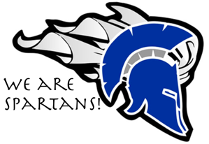

Dear Parents and Guardians,

We are very excited to have your student join us next year here at South Cache Middle School. Our faculty is committed to providing each student with every opportunity for success as he or she passes through our halls. We have a wonderful staff and a caring atmosphere that we know will help nurture your child both academically and socially over the next two years. Making the transition from elementary school to middle school can be intimidating for both parents and students, especially with the first child in a family, but it is a natural part of growing up and nothing to fear. Hopefully this letter will provide some information that will help ease that transition.
Your student should have a registration form along with this letter. Please take a moment to get online and register together. Step by step instructions are included in this packet.
If you don’t have internet access please have your student return the registration form to his/her 6th grade teacher. We will be visiting each school to collect the forms. If your student does not return the form to his/her teacher, we will have him fill one out during our visit.
Schedules will be made available before school starts in August. Watch for a summer letter that will have more information and important dates.
Parents often have concerns regarding the classes their children are assigned; unfortunately, we cannot guarantee requests for specific teachers. Changes in enrollment, staffing and teaching assignments all have an impact on the availability of classes. Parents, of course, have special insights into their children’s personalities and we need to know of situations that may require special consideration. You are welcome to call us.
Once your student has received his/her schedule, you are more than welcome to help them find classes, open lockers, and learn the layout of the school. Experience has shown that the biggest worries of incoming 7th graders include riding the bus, finding classrooms and lockers, finding the lunchroom and meeting new people. Anything you can do to help prepare your child for those things will help smooth the transition to the new school.
It seems incredible that we are already talking about next year, but here we are. We can’t wait for all of our new students to get here. If you have any questions about what to expect or what is expected, remember to look for the summer letter near the end of July.

Please see our website for upcoming events and information. https://www.ccsdut.org/Domain/506

South Cache Counselors,

Kristin Davis A-G Jared Smith H-N Melanie Francis O-Z

